

MOBILE

[**Project based exam-II]**

Team-6

Name Class ID UMKC ID

Chakradhar Chinnam 09 16291617

Harun Sai Kumar Gente 16 16294902

Sai Haneesh Tanneru 37 16290739

**Introduction:**

* The mobile application we have developed is a **Weather App**. In this application we can display the weather forecast for any desired and current location. Our app is also used for displaying forecast for 5 days. Apart from the above features our application also gives information about the wind speed and humidity of the entered location. All the details of the forecast will be stored in SQLite database.

**Objectives:**

* Developing a Android Mobile Application called “**Weather App**”
* Used OpenWeather Map API to get the temperature of the location and OpenWeather Forecast API to get the further 5 day forecast.
* Used SQLite database to store the previous searched results.
* Established a clear communication between components, activities with an attractive UI by adding a background.
* Used a hardware component GPS to display the weather in our current location.

**Technologies Used:**

* Android Studio
* SQLite
* SQLite browser
* Java
* XML

**Working Model:**

* When the App launches it asks the user to enter the desired location to know the temperature.
* We have written a Java code such that the entered location will trigger both the APIs used and gives the current temperature, wind and humidity along with a 5-day forecast.
* As an additional feature to the app we have added a hardware component ‘GPS’ to track the current location of the mobile device and display the weather conditions.
* All these details like location name, temperature, wind and humidity will be stored in SQLite database.
* We used our Android mobile device as an emulator to display the output.
* We can access the database by installing SQLite browser in our local system.
* Database path:

**data/data/<package-name>/<your-db-file>**

* Used Android Studio to implement the Application with Java as a backend and XML layouts for frontend page to display.

**Source Code:**

**1.To display the home page of the Application with location.**

**Java code for adding the location:**

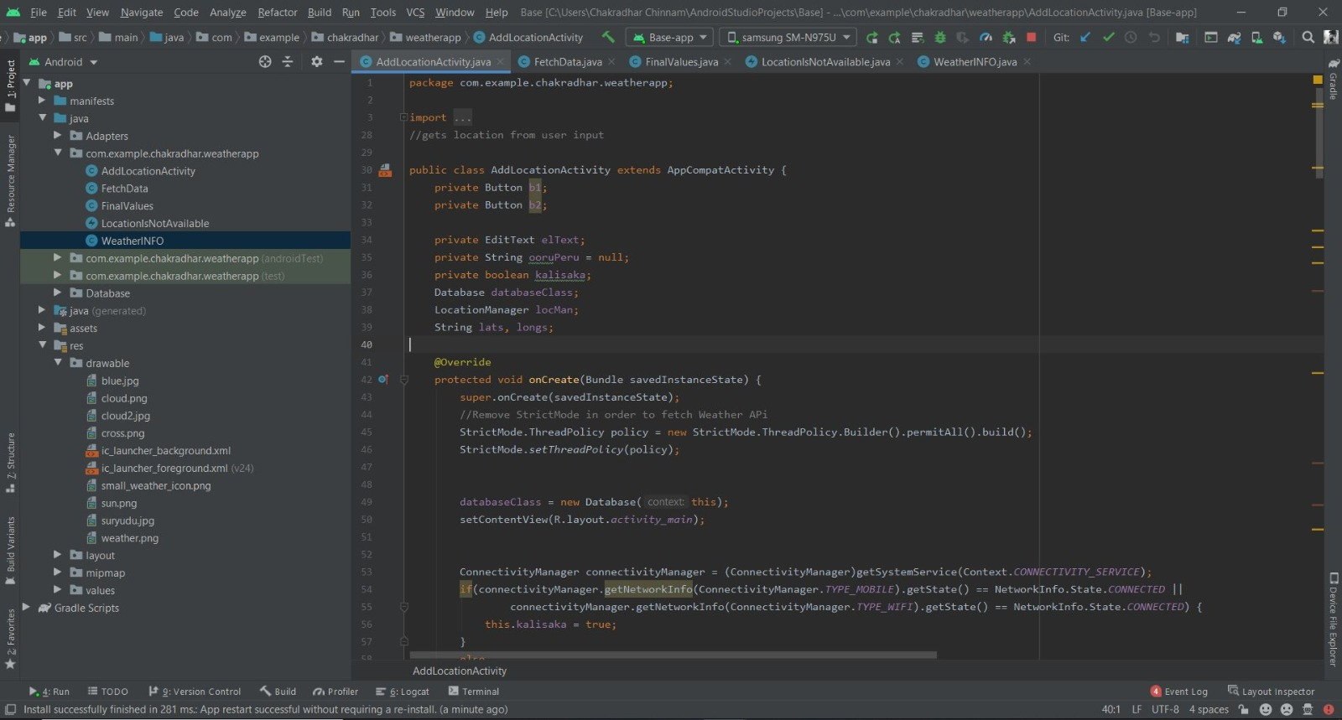

**Corresponding XML code for the home page:**

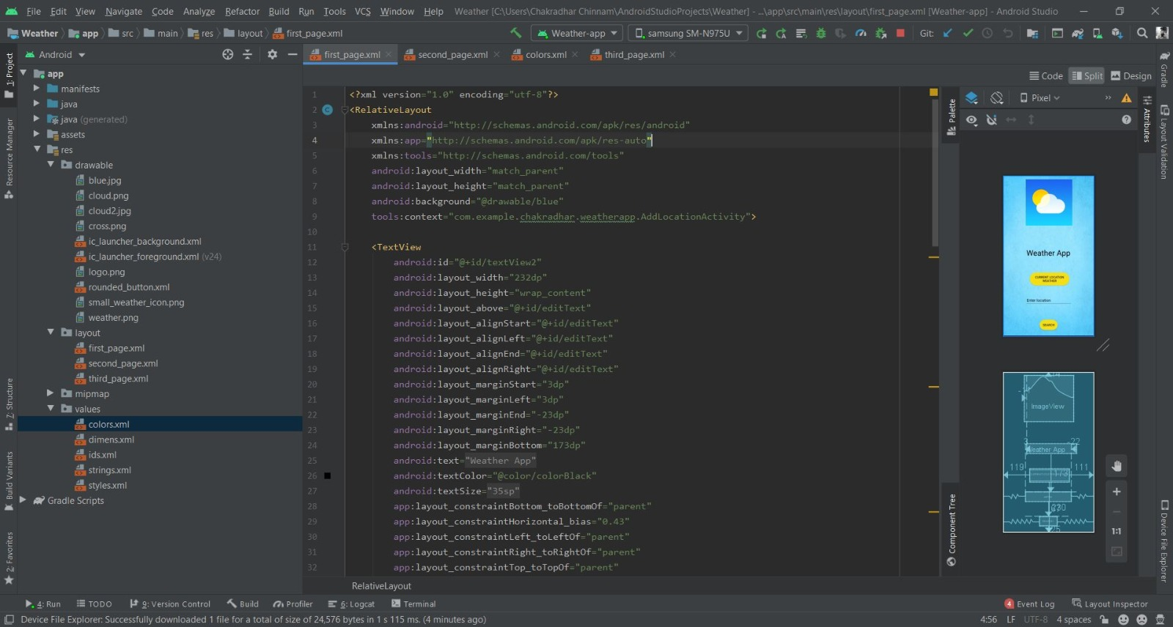

**Output : App with icon:**

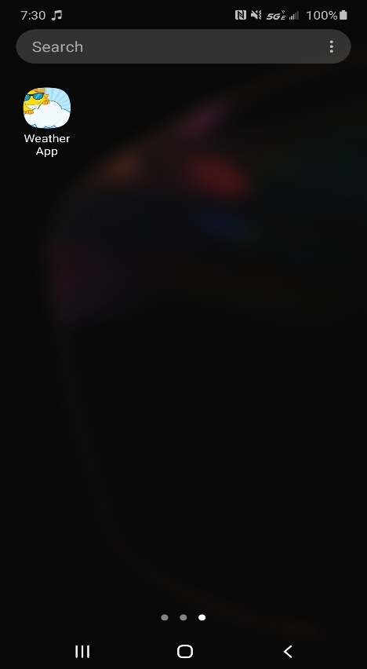

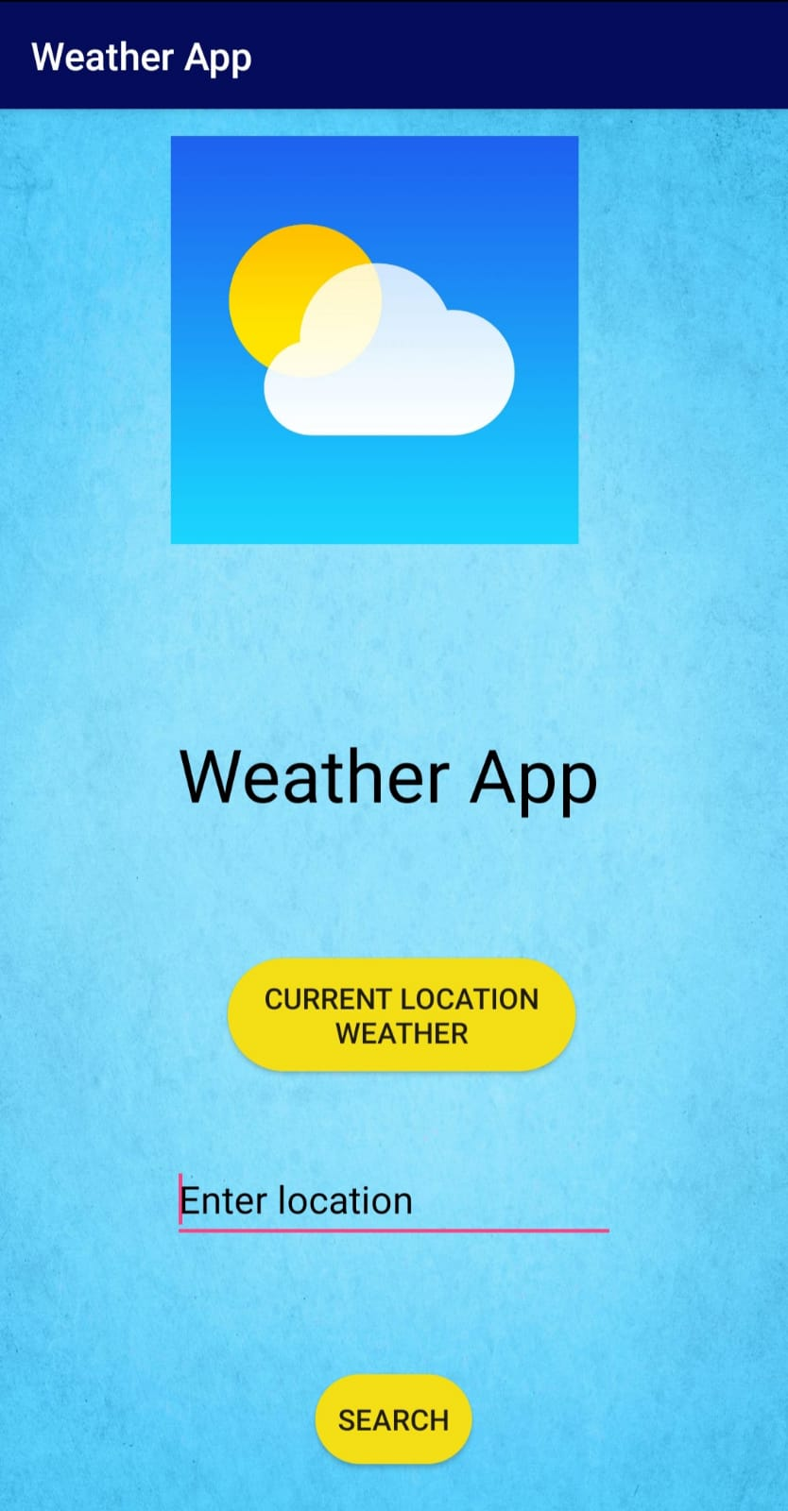

**If we click on the button “Find Current location weather” it will display your current location’s[using GPS] weather forecast as below:**

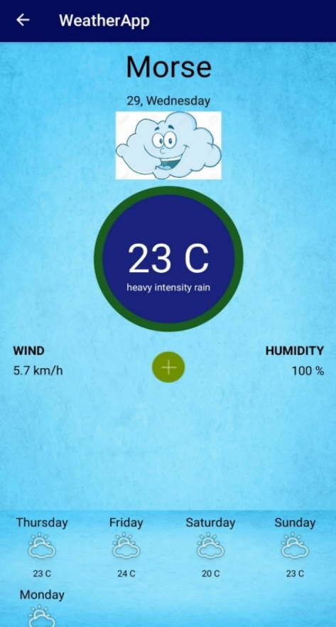

**2.To fetch the input location from the APIs to display the temperature,wind and humidity.**

**Java Code to display the information:**

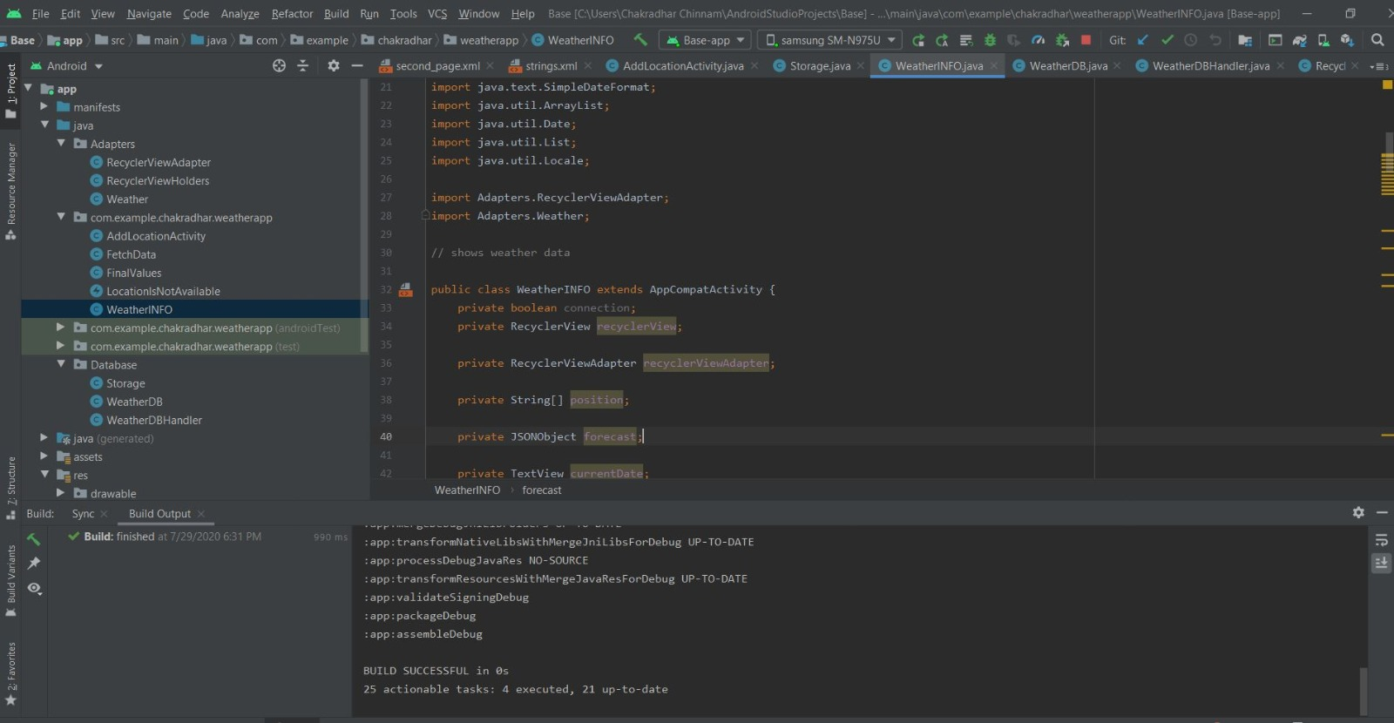

**Java code for fetching the data:**

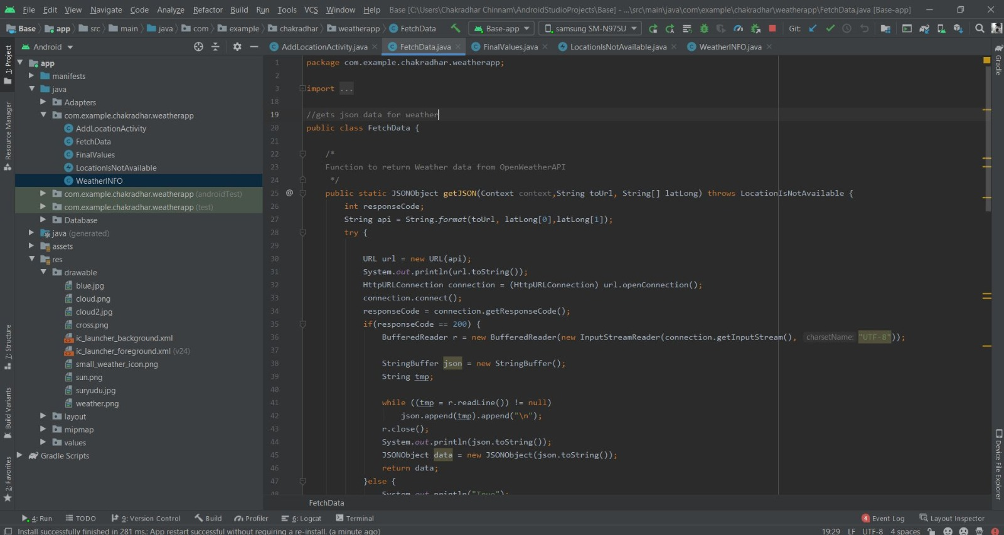

**APIs**

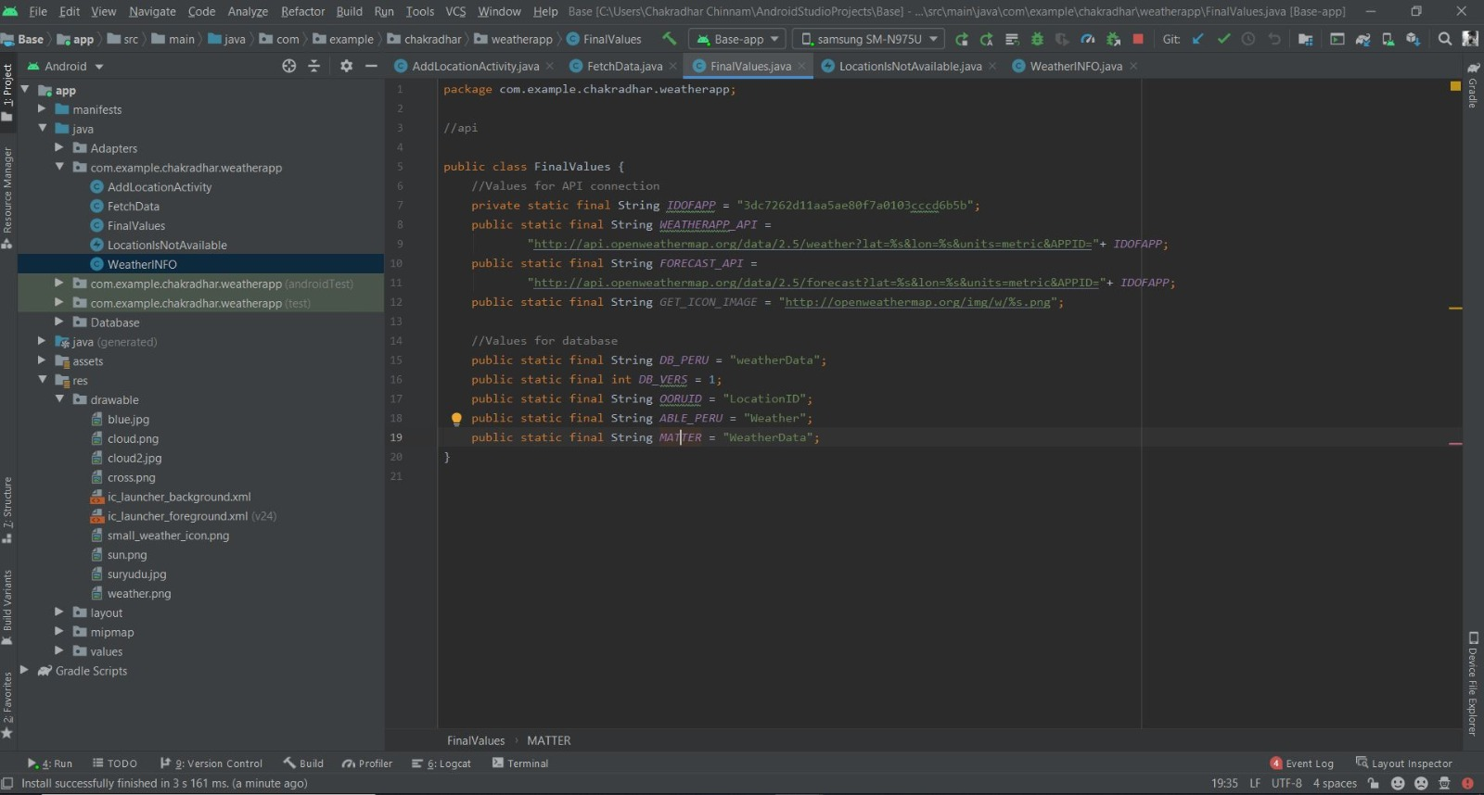

**Corresponding XML file for displaying temperature, wind and humidity:**

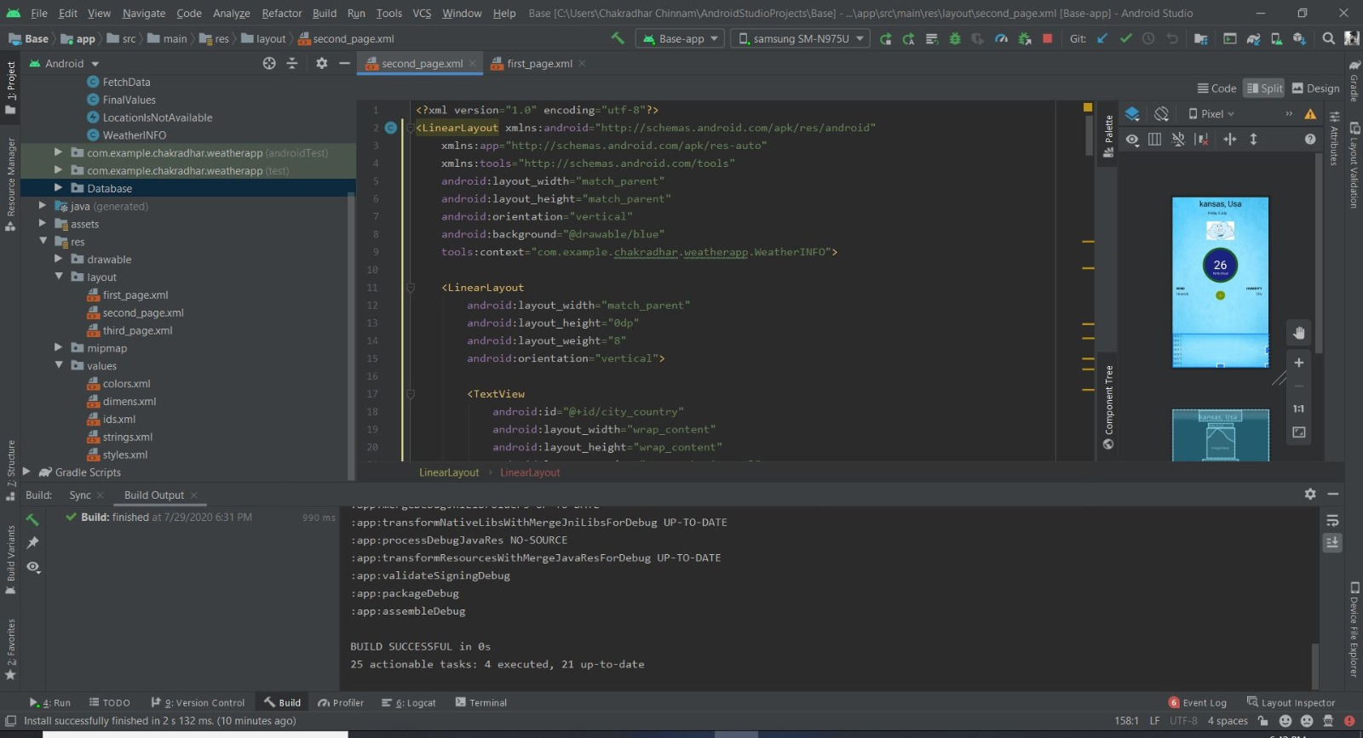

**Corresponding XML file 5-day weather forecast:**

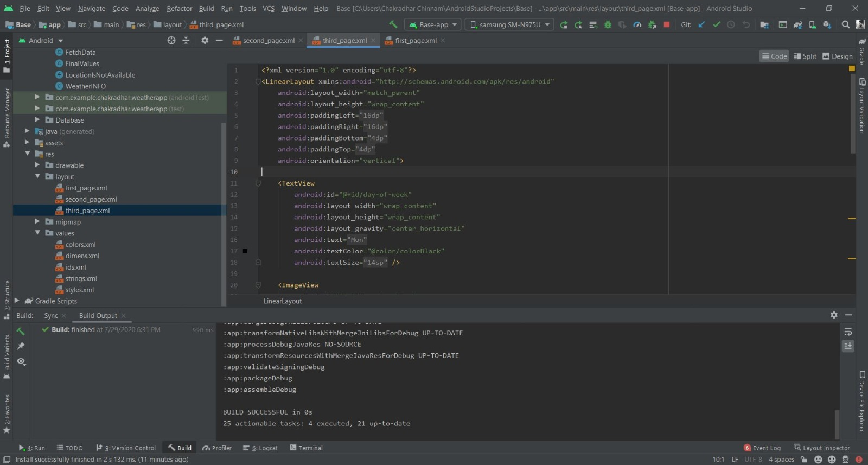

**Output:**

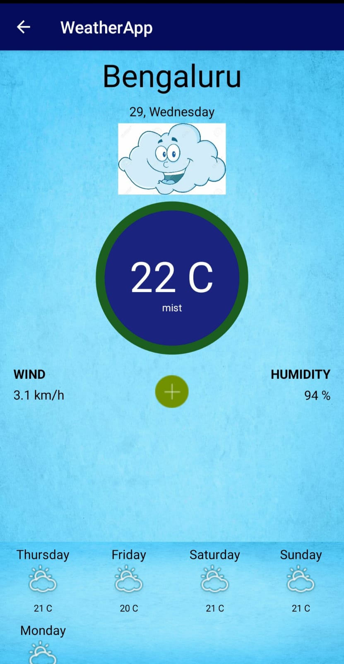

**If the user entered location is not found:**

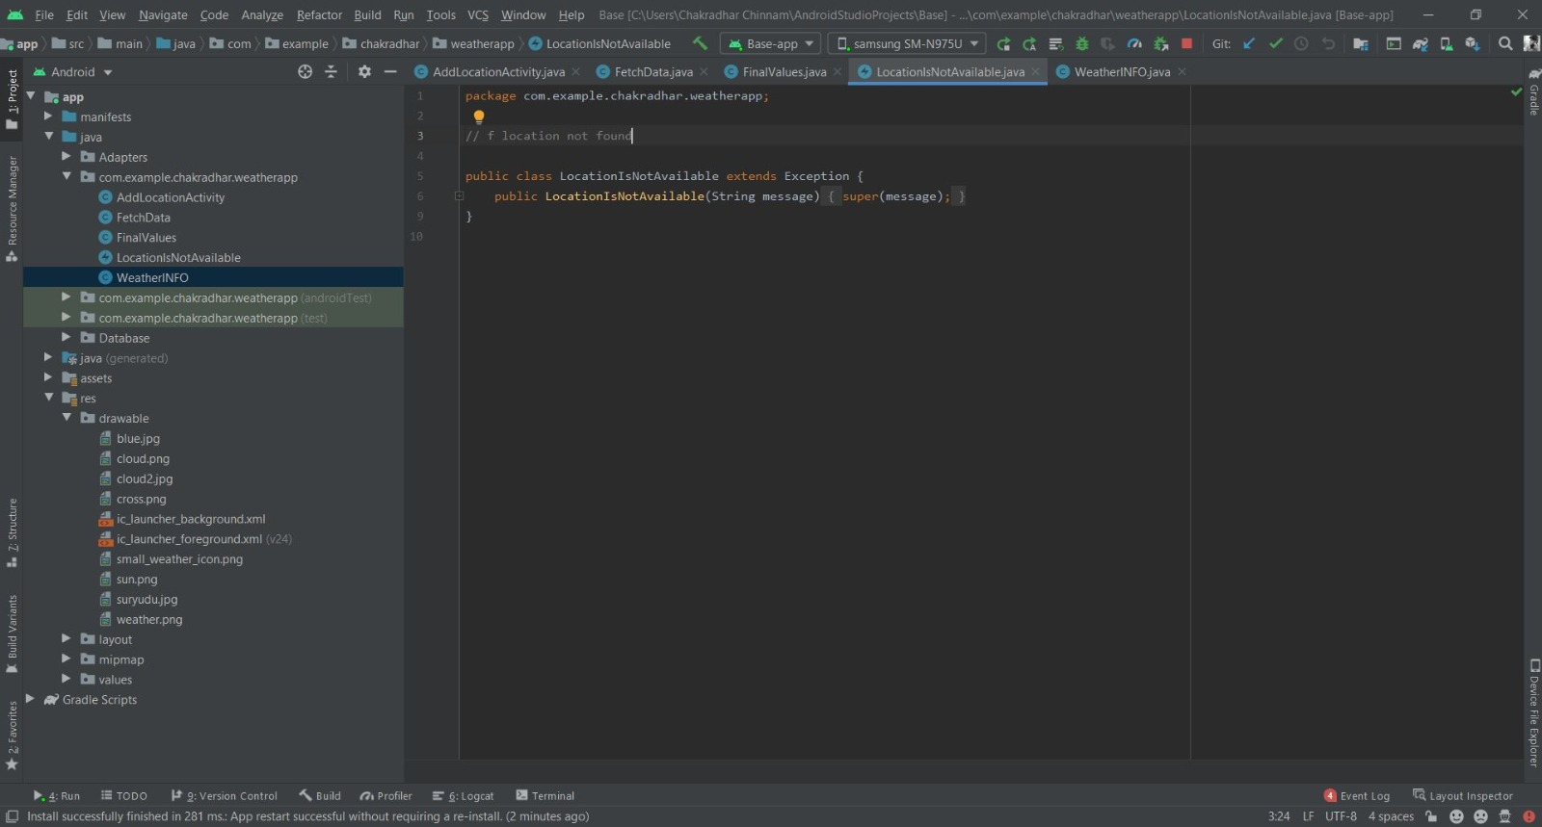

**Output:**

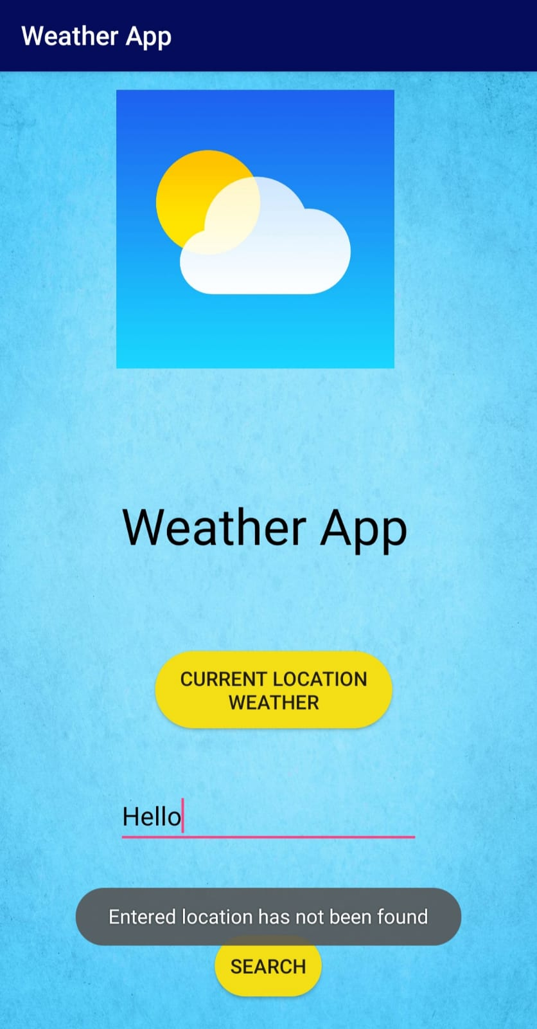

**Data stored in the SQLite database:**

**Java Code:**

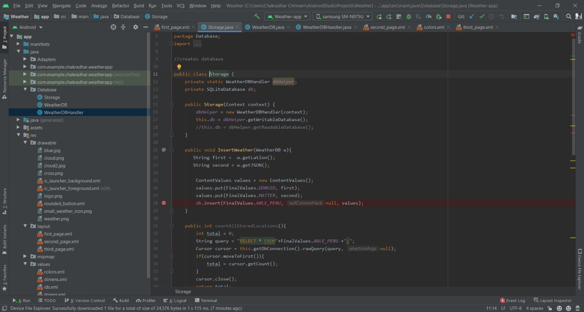

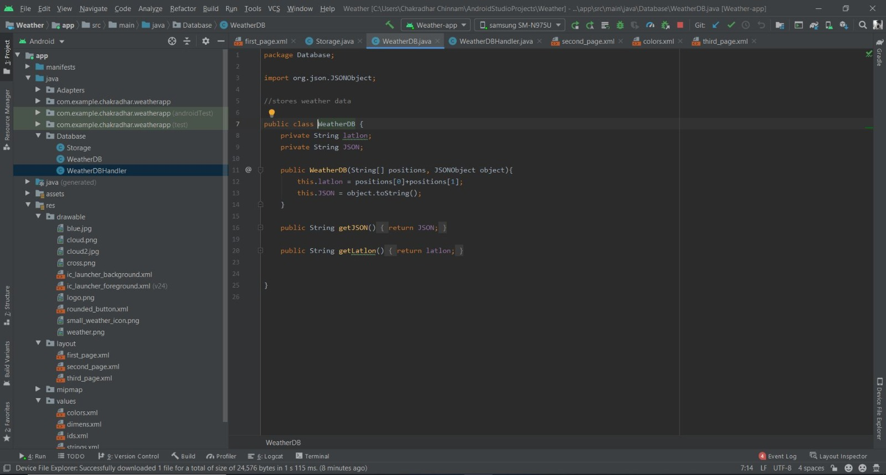

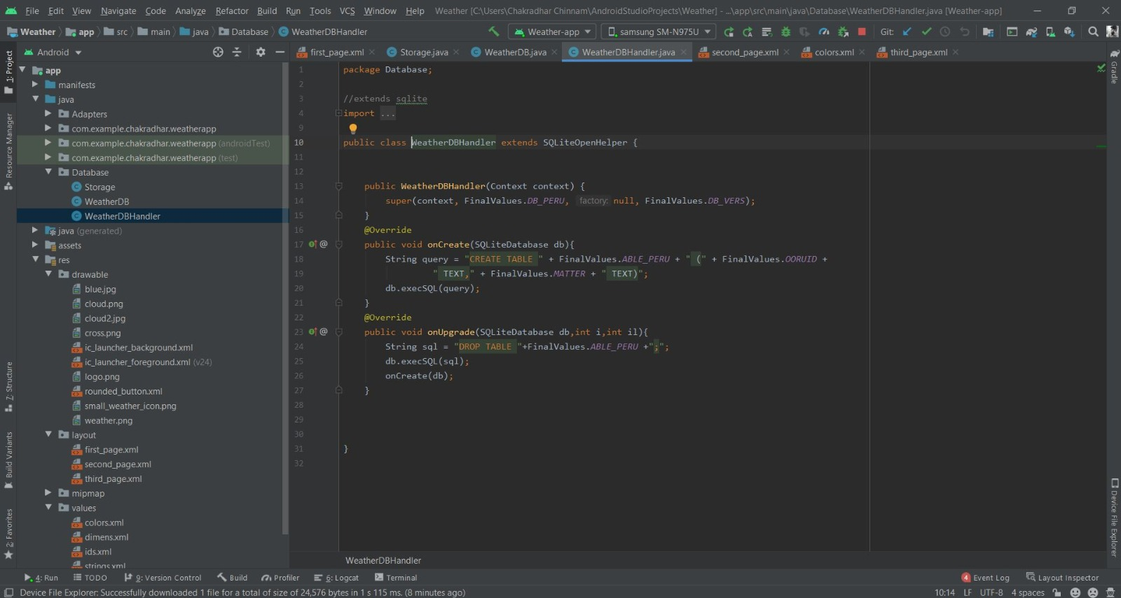

**Output:**

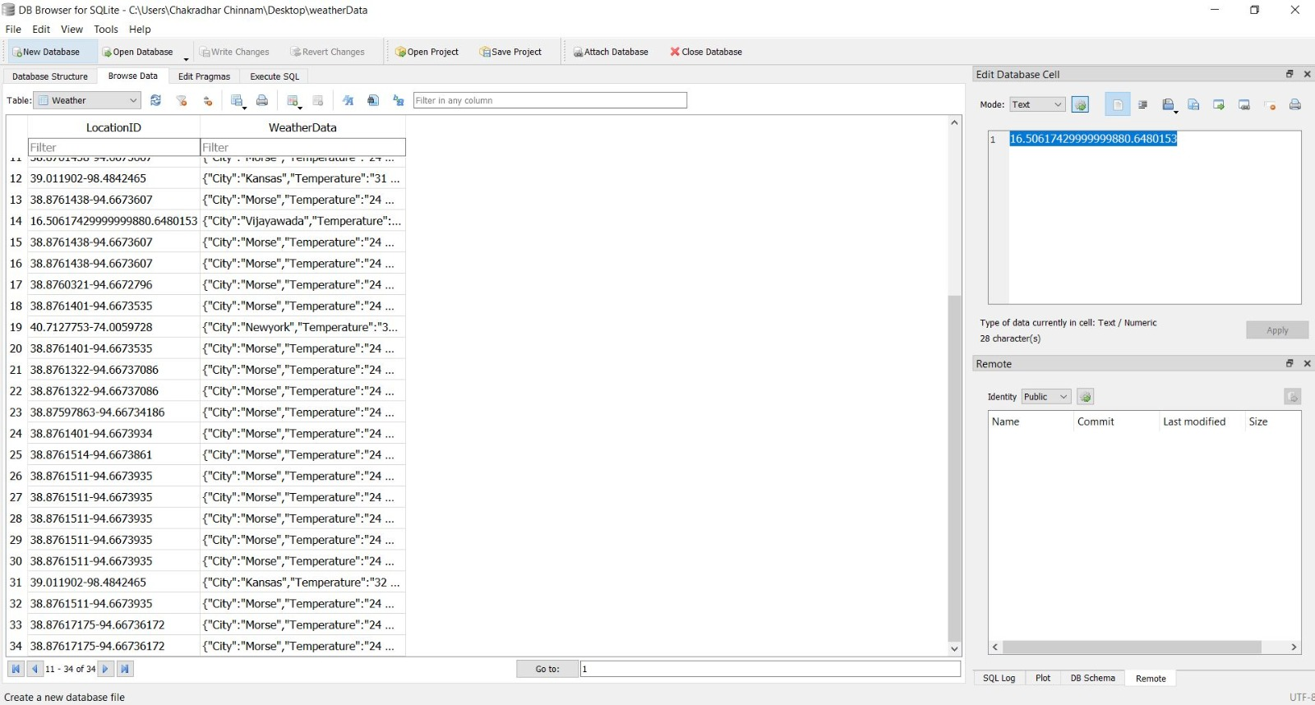

**Contribution:**

Chakradhar Chinnam (33.34%)

Harun Sai Kumar Gente (33.33%)

Sai Haneesh Tanneru (33.33%)

All of us made equal contribution and every person was involved in developing the mobile application.

**Challenges/Issues:**

* Adding the hardware Component GPS to the application.
* Working with SQLite.
* Integrating with APIs.

**Github Link:**

<https://github.com/chakradharchinnam/WebMobile_2020Summer/wiki/Mobile-Project>

**Video Explanation Link:**

<https://umkc.hosted.panopto.com/Panopto/Pages/Viewer.aspx?id=d66431b5-d642-4833-820a-ac08003544a1>

**References:**

<https://www.tutorialspoint.com/android/android_sqlite_database.htm>

<https://www.tutorialspoint.com/java/index.htm>

<https://www.w3schools.com/xml/xml_whatis.asp>

**Conclusion:**

Hence, the app we have developed can be used to check the weather of the desired as well as current location of your in the world. All the weather and location details are stored in SQLite database as the Android mobile application is integrated with SQLite.